The Boy Scouts of America Troop 390 presents its 27th Annual
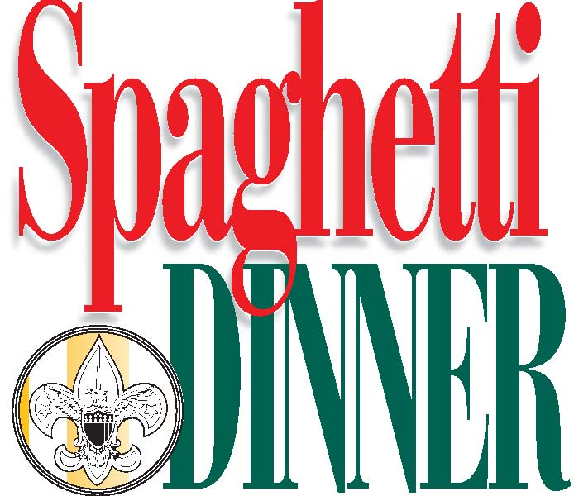
2726 West Market Street, next to Saint Hilary Church
Saturday, March 14, 2019
$8.00 adults, $5.00 kids
Dinner includes spaghetti, salad, bread, beverage, and dessert! Kids 2 and under are free!
Featuring parent-sponsored raffle for amazing gift baskets!

